

CERTIFIED PUBLIC ACCOUNTANT
ADVANCED LEVEL 1 EXAMINATIONS
A1.1: STRATEGY AND LEADERSHIP
DATE: MONDAY 23, FEBRUARY 2026
MARKING GUIDE AND MODEL ANSWERS

SECTION A
QUESTION ONE
Marking Guide
- The four grand strategies that Ngezi Ltd may undertake include:
Growth 1
Stability 1
Retrenchment 1
Global strategy 1
Growth strategy 2
(Any valid and well-explained, award 1 mark each; any stated or poorly explained point award 0.5 mark).
Maximum marks 6

- Importance of a having a good organisation structure at Ngezi Ltd
Behaviour and performance 1
Norms of behaviour 1
Morale and job satisfaction 1
(Any valid and well-explained, award 1 mark each; any stated or poorly explained point award 0.5 mark). 1
Maximum marks 4

- Key elements of Operations Management at Ngezi Ltd may include:
Forecasting demand 1.5
Job design 1.5
Method study 1
Location 1.5
Purchasing 1.5
Inventory management 1.5
Quality 1.5
Any other valid point (will attract 1.5 Marks) 1.5

Maximum marks 10

- Functions within the marketing department at Ngezi Ltd include:

Market research 1
Sales 1
Promotions 1
Distribution 1
(Any valid and well-explained, award 1 mark each; any stated or poorly explained point award 0.5 mark).

Maximum marks 4

- i. Advantages to Ngezi Ltd of segmenting the market according to geographical location, income, and age group:
Definition of market segmentation 1
Identify new product opportunities 1
Improved profits 1
Specific customer needs identified 1
Control the market 1
Any other valid point (will attract 1 Mark) 1
Maximum marks 5

ii) The Marketing mix to be deployed by Ngezi Ltd
Product 1.5
Price 1.5
Place 1.5
Promotion 1.5
Maximum marks 6

- Marketing plan:
Definition 0.5
Marketing objectives 0.5
Details of strategies and tactics 0.5
An operating plan 0.5
Details of resources 0.5
A financial budget 0.5
Maximum marks 3

- SWOT analysis at Ngezi Ltd
Strengths:
Good location 1
Profitable for over the years 1
Bulk buying 1
Use of debt capital 1
Intangible asset 1
Any other valid point (will attract 1 Mark) 1
Maximum marks 3

Weaknesses:
Lack of strategic experience 1
No technology used 1
Declining profitability 1
Poor inventory management system 1
Lack of a marketing strategy 1
Any other valid point (will attract 1 Mark) 1
Maximum marks 3

Opportunities:
Technology 1
Marketing opportunities 1
New product ranges 1
The partnership with the government 1
Development of online ordering 1
Any other valid point (will attract 1 Mark) 1
Maximum marks 3

Threats
Competition 1
Reduced profitability 1
New business entry 1
Customer loyalty may be low 1
Over-regulation 1
Any other valid point (will attract 1 Mark) 1
Maximum marks 3

Model Answers
i) The four grand strategies that Ngezi Ltd may undertake include:
Growth
This refers to a strategy that considers internal growth through expansion investments - new product development or existing product enhancement or externally through the acquisition of new business divisions.

Stability
This is referred to as the pause strategy where the organization tends to remain in the same position or grows slowly in a controlled style.

Retrenchment
This is a strategy where the organisation goes through a period of forced strategy. This usually occurs when an organization’s product or service demand falls drastically.

Global strategy
This is a strategy pursued by an organisation with a global focus. This requires the organisation’s product design and marketing strategies to equally be globally standardised.
Since Ngezi Ltd is faced with stiff competition, it needs to figure out the strategy it may deploy to remain profitable. With a good strategy it can be able to revert the current situation by developing a marketing plan and therefore stick to the growth strategy which appears to be the most effective in this case.
- Importance of a having a good organisation structure at Ngezi Ltd

Clarifies roles and accountability so staff know what is expected in implementing the strategy (a key gap identified by the Board Chair).
Enhances communication and decision-making so strategy, targets, and KPIs are understood, communicated, monitored, and measured.
A good structure will influence the behaviour and performance of Ngezi Ltd staff since a guidance that lays out the official reporting relationships that govern the workflow shall have been produced.
As a company is a social system, staff at Ngezi Ltd will be able to establish their own behavioural norms and social groups independent of those defined in the formal structure.
Poor organisation structure may contribute to the poor performance of Ngezi Ltd.
A poor organisation structure not only affects the productivity and economic efficiency of staff but also their morale and job satisfaction.

- Key elements of Operations Management at Ngezi Ltd may include:
Forecasting demand
This will help Ngezi to plan accordingly on the aspects of production runs, irish potato inventory and resourcing depending on how the market will have reacted.

Job design
Ngezi Ltd will have to carry out a work study to ensure that waste is eliminated thereby saving costs whilst increasing production.

Method study
This will involve measuring and developing the best methods of performing tasks.

Location
Since the factory is already located in the northern province near the source of irish potatoes, Ngezi Ltd may not necessarily have to do much on the factory location though some costs are incurred to distribute the packaged crisps to the market.

Purchasing
To ensure there is adequate stock of irish potatoes, Ngezi Ltd may have to purchase enough of them and put them in storage facilities to mitigate the possibility of stock outs. Power is a bit of an issue as road shedding is quite rampant in the factory area. Purchase of a generator may be considered.

Inventory management
To guarantee that the factory space is well utilised, Ngezi Ltd will have to ensure that already made crisps should immediately be transported to the distribution centres and the same delivery vans return with irish potatoes. Just in time inventory management system may not be appropriate as farmers can easily sell them off to other dealers.

Quality
To ensure that the quality of the finished product is well maintained, Ngezi Ltd will need to carry out quality control checks during and after production. A culture of making each employee feel that quality is everyone’s responsibility should be created and supported.
- Functions within the marketing department at Ngezi Ltd include:

Market research
This refers to the process of conducting research such that Ngezi Ltd will be able to enhance its prospects of selling crisps.
Sales
This is concerned with the sales team at Ngezi Ltd personally contributing to the direct selling of the crisps.
Promotions
Selling may not be adequate without the team to conduct advertisements and public relations. Some of the activities that may be carried out at Ngezi Ltd may include trade fairs and exhibitions.
Distribution
This requires Ngezi Ltd to identify and select appropriate channels through which crisps should be distributed.
e)
Ngezi Ltd
Musanze District, Northern Province, Rwanda

Date: 22 /11 / 2021

To: The Board of Directors, Ngezi Ltd
Attention: Mr Alex Kamana, Board Chair

RE: Market segmentation, marketing mix, and marketing plan recommendations
Dear Board Members,
Following the Board’s concerns regarding increasing competition, changing customer preferences, customer switching risks, and the absence of a marketing plan, I submit the following strategic recommendations.
- Market segmentation
Market segmentation is a proven strategy for achieving success. It is the process of dividing a broad market into various homogeneous segments so that products can be presented in a manner that directly appeals to them. For instance, segmentation can be based on factors such as sex, age group, geographical location, and income.

Advantages to Ngezi Ltd of segmenting the market according to geographical location, income, and age group:
Ngezi Ltd will be able to identify new product opportunities. For example, if the current crisps are considered to be expensive, less expensive crisps could be processed with a different size and packaging.
Ngezi Ltd would realize improved profits through an increase in sales as it will be possible to avoid unprofitable markets.
Customer loyalty and reduced switching: By meeting segment-specific needs consistently (quality, availability, value), Ngezi builds loyalty and reduces risk of customers shifting to cheaper rivals.
Specific customer needs will be more easily identified, a move that will thereafter facilitate production of an accurate marketing budget.
Ngezi Ltd will be able to control the market and protect itself from competition by again producing crisps according to each market segment needs.
Customer loyalty and reduced switching: By meeting segment-specific needs consistently (quality, availability, value), Ngezi builds loyalty and reduces risk of customers shifting to cheaper rivals.
- The Marketing mix to be deployed by Ngezi Ltd
Product - A poorly conceived product or service can never be sustained. Product policy may include research and development, the way the crisps are packaged, labelled and branded. Ngezi should consider packaging its products in biodegradable materials to avoid being boycotted due to environmental concerns whilst considering a lesser expensive packaging for the new market segment of cheap crisps.

Price - This refers to the monetary value attached to the product or service. It covers pricing, discounts and whether Ngezi Ltd can also offer credit sales. Ngezi Ltd should consider offering discounts as promised or else it segments the market in order to have prices for each distinct segment.

Place - This would include all distribution activities and it’s about getting the right product to the right place in the right quantities at the right time. There are generally three types of distributors used in marketing and distribution and these are: agents and brokers, retailers and wholesalers. Ngezi Ltd should make use of agents and wholesalers to distribute crisps countrywide but also consider using its website to encourage online ordering.

Promotion - These attempt to persuade people to respond in a manner desirable to Ngezi Ltd through the usage of a wide range of communication methods. Examples include personal selling, advertising, public relations, and sales promotions. Ngezi Ltd can consider enhancing its advertising strategy and also encourage personal selling to the people that are already known to staff.
- Key components of an effective marketing plan
Marketing plan: This explains where an organization intends to be in future and the tactics of getting there. A marketing plan entails five components:
1. A statement of the marketing objectives for the current and future period, including new products the company may introduce and as well as operational markets.
2. Details of strategies and tactics to be used to achieve the objectives.
3. An operating plan for the period defining the role of each department and major section and activities to be undertaken.
4. Details of resources, staff equipment, finances etc.
5. A financial budget detailing the needed running costs, and the monthly expenses that will be required to achieve each element of the plan.

f) SWOT analysis at Ngezi Ltd
Strengths:
The company is located in a good location compared to its competitors. Good location of a business may also significantly boost a company's long-term performance.

The company has been profitable for over the years. The profits that were made in the previous years could be used as a competitive advantage in circumstances when times are bad.

Bulk buying offers the opportunity of competitive prices through offered discounts. When Ngezi Ltd purchases in large quantities, it has the flexibility of choosing from a broad variety of potatoes from all the leading irish potato suppliers.

Use of debt capital that results in tax savings as opposed to equity capital offers Ngezi Ltd an opportunity to maximize growth, profit, and shareholder value.

The intangible asset of Mr Shema’s connection with the Rwanda Agriculture Board where he got some advice on how to improve irish potato varieties along with other improved agronomic practices.

Weaknesses:
Lack of strategic experience of some members of the management team which may lead Ngezi Ltd to miss out on some identifiable business objectives.

No technology used and there is also an apparent lack of expertise to be able to develop the needed technology which plays a vital role in every sphere of life.

Declining profitability of the company which is either a function of declining sales or increasing expenses at Ngezi Ltd.

Poor inventory management system which may lead to stockouts. This is one of the reasons as to why most businesses fail, Ngezi Ltd should work on this urgently if it wants to remain profitable.
The apparent lack of a marketing strategy could be the reason Ngezi Ltd is struggling yet with an appropriate marketing mix it may be able to reverse the current situation and gets back to the performance of the yesteryears.

Opportunities:
Adopting advanced Technology developments in the company could assist the organization to prosper though this may come at some extra costs.

Once technology is adopted, marketing opportunities could be enhanced since Ngezi Ltd can also use other various avenues to get its products known to the market at a relatively faster rate.

New product ranges with higher margins could be developed and sold. If one of the proposals points at Ngezi Ltd expanding its product line, this could be an opportunity for consideration.

The partnership with the government in developing value adding measures coupled with the provision of advisory services to both farmers and seed producers, multiplication of quality potato seeds and the strengthening of the potato research program provides an opportunity to Ngezi Ltd in this area.

Development of online ordering such as order and collect as well as home deliveries. Ngezi Ltd will have an opportunity of selling at higher margins as with online selling, Ngezi Ltd will be dealing with the final consumer as opposed to selling through other brokers.

Threats
The competition level is high which lowers the prices that customers should be sold at.

Price competition may reduce profitability which is yet another threat At Ngezi Ltd as it appears some competitors are already selling at a lower price to Ngezi Ltd.

New businesses could enter the market relatively easily if Ngezi Ltd continues to fail to apply an appropriate market strategy that will increase its market share.

Customer loyalty may be low as customers may easily switch to competitors and it appears that Ngezi Ltd has failed to keep up with customer expectations including failing to offer the promised discounts.

The sector is likely to be over-regulated by the government which may impact on Ngezi Ltd if further restrictions are imposed.

SECTION B
QUESTION TWO
Marking Guide
Qn | Description | Marks | Total Marks
a) (i) | SAKWESAKWE's Kurt Lewin Force Field Analysis:  Answers should be based on a diagrammatic illustration of the forces for and against change, and well justified
a) (i) | A good introduction or description of Kurt Lewin's Force Field Analysis | 2
a) (i) | Award 2 marks for a correct advice/decision (No Change) | 2
a) (i) | Award 2 marks for a correct justification for not recommending change (Forces against change outweigh forces for change, i.e., 14 vs 13) | 2
a) (i) | Diagram:
a) (i) | Driving Forces (Award 0.5 marks for a correct arrow with a correct score line):
a) (i) | Enhanced security and reduced fraud risk | 0.5
a) (i) | Competitive advantage through modern biometric login | 0.5
a) (i) | Future-proofing the app for broader use and compliance upgrades | 0.5
a) (i) | Restraining Forces (Award 0.5 marks for a correct arrow with a correct score line):
a) (i) | Delay in project delivery timeline by 2+ months | 0.5
a) (i) | Breach of contract scope; may require client renegotiation | 0.5
a) (i) | Increased project cost not budgeted by the client | 0.5
a) (i) | Developer unfamiliarity with biometric libraries | 0.5
a) (i) | A valid change title in the middle of the diagram | 0.5 | 10
a) (ii) | Recommendations for making the change more favourable:  Answers do not need to be detailed, but must be sufficiently and clearly described  NB: Alternative valid answers offered by candidates but not in the model answer are acceptable
a) (ii) | Award 2 marks for any valid recommendation, i.e., 2 marks for 3 recommendations (Award 1 mark if the answer is not sufficiently or clearly described) | 6 | 6
b) | Project progress report for the Banking App Project:  Answers should be presented in a professional report format
b) | Report title | 0.5
b) | Author, i.e., Project Manager | 0.5
b) | Date, i.e., 15 September 2025 | 0.5
b) | Addressee, i.e., CEO | 0.5
b) | Project overview or summary | 1
b) | Achievements (0.5 marks * any 3 points) | 1.5
b) | Remaining/uncompleted work (0.5 marks * any 2 points) | 1
b) | Timelines, i.e., new completion date | 0.5
b) | Risks and issues (0.5 marks * any 2 points) | 1
b) | Recommendations (0.5 marks * any 2 points) | 1
b) | Sign off (any formal sign off is acceptable) | 0.5
b) | Signature (This could be an actual signature or the word project manager, or an actual name) | 0.5 | 9
Total Marks |  |  | 25

Model Answer
- With reference to Kurt Lewin Force Field Analysis and with the help of an appropriate diagram:
  - Advise whether SAKWESAKWE Ltd should adopt the proposed change to implement biometric authentication.
Kurt Lewin suggests that change is the outcome of the impact of driving forces on restraining forces, more commonly known as the force field analysis.
Force-field analysis grew from the work of Kurt Lewin, who proposed that change was a result of the competition between driving and restraining forces. Driving forces can be thought of as problems or opportunities that motivate change within the organization. Restraining forces are the various barriers to change, such as a lack of resources, resistance from middle managers, or inadequate employee skills. When a change is introduced, managers should analyse both the forces that drive change (problems and opportunities) and the forces that resist it (barriers to change). By selectively removing forces that restrain change, the driving forces will be strong enough to enable implementation.
Based on the Force Field Analysis presented, SAKWESAKWE Ltd should not proceed with implementing the biometric authentication change at this stage of the Banking App Project. While the proposed change has strong advantages-including improved security (score 5), competitive positioning (score 4), and long-term scalability (score 4)-the forces resisting the change outweigh the driving forces, with a total score of 14 against versus 13 for. See figure 2.1 below.
Key concerns include the risk of project delays, a potential breach of contract terms, budget overruns, and technical skill gaps among developers. These issues could damage the company's reputation, delay client satisfaction, and increase costs without clear agreement or additional budget allocation from the client.
In line with Lewin’s model, the equilibrium currently favours maintaining the status quo, especially considering that the project is already 70% complete and the client has not expressed a need for the proposed upgrade.
Figure 2.1: Force Field Analysis Diagram
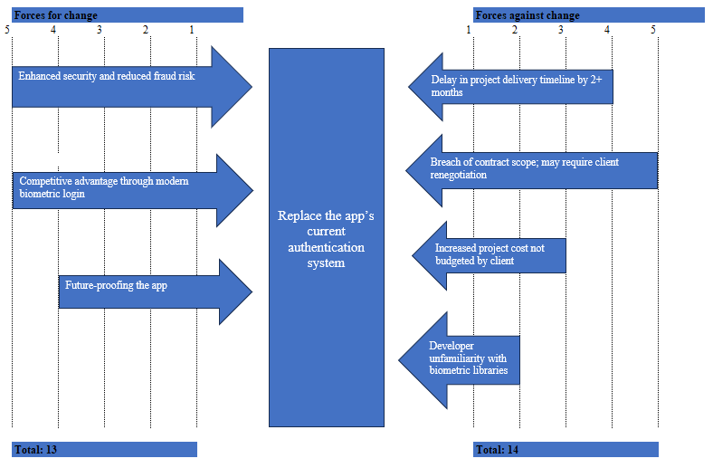
  - Recommend ways through which management may reduce forces against the change and make the change more favourable to all parties.
To make the change more acceptable to both the client and the project team, SAKWESAKWE management may consider the following strategies:
    - Negotiate an updated contract with the client: Engage Bank of Kirehe in a structured conversation to propose a revised project scope and timeline. Present the security benefits and offer to co-fund or phase the upgrade after the initial app launch to reduce disruption.
    - Secure additional funding or support: Seek innovation grants, subsidies, or third-party partnerships to cover the additional FRW 12 million cost, so that the client does not bear the full financial burden.
    - Build internal capacity for biometric integration: Invest in training or short-term hiring of biometric system developers. This would mitigate the technical skill gap and ensure a smoother transition if the change is adopted in the future.
    - Introduce change incrementally: Rather than implement biometric authentication immediately, schedule it as part of a future version updates post-deployment. This approach ensures the current delivery timeline is preserved while laying the groundwork for innovation.

- Using the project status information in the case study, prepare a project progress report for the Banking App Project to be submitted to the Client.
Progress Report - Banking App Project
Prepared by: Project Manager, SAKWESAKWE Ltd
Date: 15 September 2025
Submitted to: Chief Executive Officer, BANK OF KIREHE
1. Project Overview
This report outlines the status of the mobile banking application being developed for BANK OF KIREHE by SAKWESAKWE Ltd. The project commenced in January 2025 with a target completion date of end of June 2025. The current progress stands at 70% completion, and final delivery is now projected for late October 2025, following minor delays linked to module refinement and internal testing.
2. Achievements to Date
The following key modules have been completed and passed internal unit testing:
- User registration and login system (currently password-based)
- Balance enquiry and transaction history
- Peer-to-peer fund transfers
- Core banking system integration
Initial client feedback has been highly positive, particularly regarding the intuitive interface, quick response time, and integration quality. There have been no significant bugs during internal testing phases so far.
3. Remaining Work and Timeline
The remaining components are:
- Development and testing of the loan application workflow (30% to complete)
- Integration of push notification alerts (under development)
- Full app testing (UAT), client review, and adjustments
- Security review and app store deployment
The updated project timeline anticipates completion of all components and deployment by 31 October 2025, provided no further scope changes are introduced.
4. Risks and Issues
- A proposal to switch to biometric authentication was discussed internally, but it risks causing major delays and cost overruns. This proposal has not been approved and will be deferred unless formally accepted by the client.
- The team is operating near full capacity; any further change requests may compromise the timeline.
- There is a minor risk of delay due to limited testing devices for Android/iOS compatibility, but mitigation efforts are underway.
5. Recommendations
- Continue with the current password-based authentication system to ensure timely delivery.
- Defer biometric features to a future project phase, subject to client interest and available budget.
- Conduct a client demonstration at 85% completion to secure early feedback and build confidence.
- Maintain weekly check-ins between the project lead and client focal point to avoid misalignment.
Please let me know if you would like to discuss the contents of this report in a meeting or if you have any questions or concerns.
Kind regards.
Project Manager
End of Report

QUESTION THREE
Marking Guide
Qn | Description | Marks | Total Marks
a) | ZIRAKAMWA's results chain:  Answers should clearly identify different categories of the results chain from the case study and demonstrate effectiveness
a) | A good introduction or description of the results chain | 2
a) | A valid diagram of the results chain | 2
a) | Award 2 marks for a valid discussion on each element of the results chain. i.e., Inputs; Activities; Outputs; Outcomes; and Impact. Award 1 mark if examples from the case study are only provided, with no discussion. | 10
a) | Overall Effectiveness Assessment (Award 1 mark for an overall verdict, which should be that the project is meeting its objectives despite some challenges) | 1 | 15
b) | The role of Mr. Kabanda George in setting the company’s strategic direction:  Answers should be sufficiently discussed and in the context of ZIRAKAMWA  NB: Alternative valid answers offered by candidates but not in the model answer are acceptable
b) | A good introduction or description of Strategic direction | 2
b) | Award 2 marks for any valid, well-explained role, to a maximum of 4 roles (Award 1 mark if the answer is not sufficiently or clearly discussed) | 8 | 10
Total Marks |  |  | 25
Model Answer
- Using the results chain tool, evaluate the effectiveness of ZIRAKAMWA Ltd’s ‘Gotomera Kibondo’ social project.
A results chain is a tool that shows how a project team believes in a particular action it takes, leading to some desired results. More specifically, for conservation projects, a results chain represents a team’s assumptions about how project or program strategies will contribute to reducing important threats, leading to the conservation of priority targets. In essence, results chains are diagrams that map out a series of causal statements that link short, medium, and long-term results in an “if…then” fashion. Figure 4.1 demonstrates a sample results chain.
Figure 4.1: A result Chain
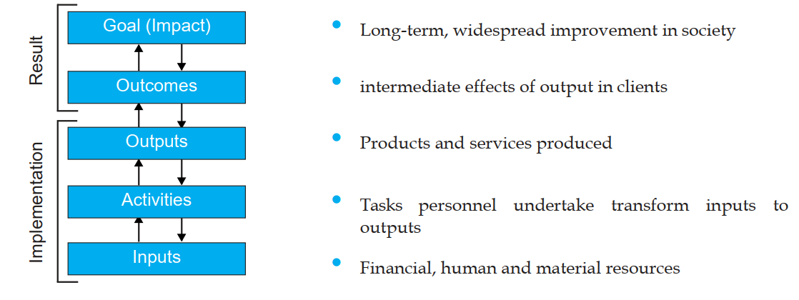
Based on the case study, the following results chain applies to ZIRAKAMWA Ltd’s ‘Gotomera Kibondo’ project:
- Inputs: The company provided raw milk, logistical support for delivery to schools, training for teachers, and collaboration with local health authorities. These were supported by staff time and transportation resources.
- Activities: Daily delivery of milk to five selected schools, boiling and serving of milk to children, and training of school staff on hygiene and handling. Monitoring of health indicators was carried out in partnership with the local health centre.
- Outputs: Approximately 800 children received daily milk servings. Teachers were trained in safe milk handling. Health staff began monitoring child nutrition levels in target schools. Daily routines were successfully established.
- Outcomes: Improved school attendance and concentration among children. Anecdotal evidence suggests better energy levels and classroom participation. Teachers report improved morning engagement and parental appreciation.
- Impact (early signs): Community goodwill toward ZIRAKAMWA has increased, and its reputation as a responsible local business has been strengthened. However, infrastructure weaknesses (e.g., limited refrigeration and transport delays) have limited full potential, especially during rainy seasons.
Effectiveness Assessment: The Gotomera Kibondo project appears to be achieving its intended short-term outcomes (health and educational participation) and laying foundations for long-term impact (reduction of malnutrition and stronger community ties). However, to ensure sustainability and scalability, the company must invest in reliable delivery systems, consider cold-chain solutions, and conduct quantitative impact assessments (e.g., stunting reduction metrics, weight-for-age trends). A feedback mechanism from parents and schools could also improve responsiveness. Overall, the initiative demonstrates strong potential, with room for strengthening in execution and monitoring.

- Discuss the role of Mr. Kabanda George in setting the company’s strategic direction.
Strategic direction refers to the clear long-term vision and path that a leader defines for an organization. It articulates where the company is going, why it matters, and how it will get there. Effective strategic direction guides planning, decision-making, alignment, and organizational culture.
As the General Manager of ZIRAKAMWA Ltd, Mr. Kabanda George plays a critical leadership role in setting and communicating the company’s strategic direction-especially as the enterprise transitions from a medium-sized dairy operation to a large, regional supplier. His influence can be understood through the following attributes:
Future Focused: Kabanda has articulated a vision of expanding ZIRAKAMWA to serve the entire Eastern Province. This long-term ambition shifts the company’s perspective from managing daily farm operations to imagining a future of regional milk distribution, increased herd sizes, and broader community engagement. His forward-thinking mindset encourages the business to build systems that anticipate future challenges rather than simply react to present needs.
Directional: The expansion strategy provides a clear roadmap-including scaling herd capacity, improving infrastructure, and professionalizing the management team. This strategic direction aligns resources and energy across the company, ensuring that daily operational decisions are connected to broader goals. It also signals to external partners (e.g., government and NGOs) that the company is evolving and worth supporting.
Specific improvements: Kabanda’s leadership is not abstract. He has focused on specific improvements such as investing in logistics for wider milk distribution and digitizing farm records to increase efficiency. This specificity enables employees and partners to act with clarity and confidence, knowing how their roles fit into the larger plan.
Relevant and Purpose-Driven: Kabanda’s strategy addresses relevant local challenges-child malnutrition, rural poverty, and low dairy consumption. The Gotomera Kibondo project exemplifies how ZIRAKAMWA’s social mission is woven into its growth strategy. By tackling these issues head-on, he ensures the company remains meaningful in the eyes of the community it serves.
Values-Based: Kabanda’s leadership style reflects family values of responsibility, community support, and ethical farming. These values shape hiring decisions, stakeholder partnerships, and even marketing messages. As ZIRAKAMWA grows, these foundational values provide a consistent ethical compass for strategic decisions.
Challenging: Pursuing regional expansion from a mid-sized base is ambitious. Kabanda has set high standards-not only in terms of output, but also governance, social responsibility, and innovation. By challenging the organization to scale while remaining grounded, he encourages staff to stretch beyond operational comfort zones.
Unique and Memorable: ZIRAKAMWA’s identity as a family-owned, socially responsible dairy farm differentiates it from corporate or government-owned milk suppliers. Kabanda’s vision is memorable because it balances commercial success with a deep-rooted commitment to local development a rare combination in Rwanda’s agri-business sector.
Inspiring: Through his inclusive leadership and visibility in community programs, Kabanda has earned the respect of his team and stakeholders. His efforts to blend technical knowledge, empathy, and ambition inspire younger staff and attract partners who believe in ZIRAKAMWA’s potential to do well by doing good.

QUESTION FOUR
Qn | Description | Marks
a | UIL's Generic competitive strategies:
a | A short and correct introduction to the Michael Porter's generic competitive strategy model | 1
a | Correctly identifying the strategy selected by UIL i.e. cost-leadership strategy | 2
a | A short description of the cost-leadership strategy | 1
a | Four key cost drivers that will help deliver UIL’s cost leadership:
a | Input costs (Award 1 mark to a short description of this driver and 1 mark to a correct explanation of how UIL applies it) | 2
a | Economies of scale (Award 1 mark to a short description of this driver and 1 mark to a correct explanation of how UIL applies it). No additional marks for the curve and no penalty for missing it. | 2
a | Experience (Award 1 mark to a short description of this driver and 1 mark to a correct explanation of how UIL applies it). No additional marks for the curve and no penalty for missing it. | 2
a | Product/process design (Award 1 mark to a short description of this driver and 1 mark to a correct explanation of how UIL applies it) | 2
a | A valid diagram/illustration of the Michael Porter's generic competitive strategy model. No additional marks for a diagram with UIL's data inside the diagram but no penalty as well | 1
 | Maximum | 13
b | BGL's Ashridge Portfolio Display:
b | A short introduction/description of what the Ashridge Portfolio Display is and its purpose or how it works | 1
b | A short explanation of the 'fit' and 'benefit' elements of the model. Award 1 mark for each element | 2
b | Correctly identifying that Cementary Limited matches with the heartland business | 1
b | Justification of why Cementary Limited is a heartland business (any one reason is sufficient) | 2
b | Correct advice that BGL should acquire Cementary Limited | 1
b | A valid diagram/illustration of the Ashridge Portfolio Display. Examples illustrated in the Ashridge Portfolio Display are not awarded extra marks and not penalised. Consider alternative correct diagrams | 1
b | Maximum | 8
b | Each reason must be explained sufficiently and linked,  Award 1 mark for each correct reason, Max 4 marks | 4
 | Total Marks | 25

Model Answers:

- With reference to Michael Porter’s Generic Competitive Strategies, identify and discuss key cost drivers that will help deliver UIL’s competitive strategy.
Competitive strategy is concerned with how a company, business unit or organisation achieves competitive advantage in its domain of activity. Competitive strategy therefore involves issues
such as costs, product and service features, and branding. In turn, competitive advantage is about
how a company, business unit or organisation creates value for its users both greater than the costs
of supplying them and superior to that of rivals. Competitive advantages should underpin
competitive strategies. In the absence of a competitive advantage, an organisation’s competitive
strategy is always vulnerable to competitors with better products or offering lower prices.

Porter’s distinctions between cost, differentiation and scope define a set of ‘generic’ strategies: in
other words, basic types of strategy that hold across many kinds of business situations. These three
generic strategies are illustrated in Figure 3.1:

Figure 3.1: Three Generic Competitive Strategies
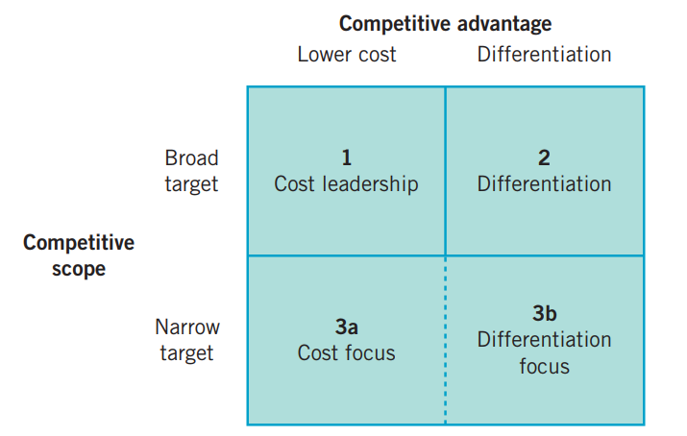
It is evident from the case study that UIL selected to pursue a cost-leadership strategy to remain competitive in the cement production industry.

Cost-leadership strategy involves becoming the systematically lowest-cost organization in a domain
of activity. Ms Clare Isimbi’s email outlines four key cost drivers that will help deliver UIL’s cost leadership:

- Input costs:
Input costs are often very important, for example labour or raw materials. Many companies seek competitive advantage through locating their labour-intensive operations in countries with low labour costs. UIL intends to reduce costs by cut down on our selling and distribution costs. Ms Clare’s email explains how they will do this by setting up a new factory in Kigali early next year for them to significantly cut down on the company’s selling and distribution costs. They will also sign a new contractor with a big regional limestone producer that will see our limestone spend fall by 20%.

- Economies of scale:
Economies of scale refer to how increasing scale usually reduces the average costs of operation over a particular time period, perhaps a month or a year. Economies of scale are important wherever there are high fixed costs. Fixed costs are those costs necessary for a level of output. Economies of scale
come from spreading these fixed costs over high levels of output (see figure 3.2). UIL intends to enjoy economies of scale by ramping up production capacity to ensure that it quickly covers huge initial fixed costs and become more profitable. By the end of next year, the company will have increased cement production by 30%.

Figure 3.2: Economies of scale
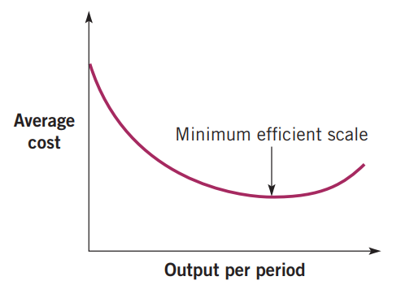

- Experience:
Experience can be a key source of cost efficiency. The experience curve implies that the cumulative
experience gained by an organisation with each unit of output leads to reductions in unit costs (see
figure 3.3). UIL intends to boost the company’s experience by hiring more qualified staff and train existing staff to raise their expertise. These efforts will reward the company with efficiency labour productivity and cost savings gained from efficiency as demonstrated in figure 3.3.

Figure 3.3: The experience curve
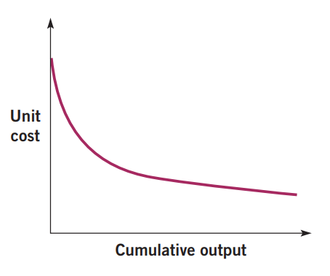

- Product/process design:
Product/process design also influences cost. Efficiency can be ‘designed in’ at the outset. UIL will further cut down its costs by replacing part of cement by ground and powdered limestone and using silica rich constituents in the form of pozzolana or slag which will reduce clinker.

b) Ashridge Portfolio Display: assess Cementary acquisition and advise
The parenting matrix (or Ashridge Portfolio Display) developed by consultants Michael Goold and
Andrew Campbell introduces parental fit as an important criterion for including businesses in the
portfolio. Businesses may be attractive in terms of the BCG or directional policy matrices, but if the parent cannot add value, then the parent ought to be cautious about acquiring or retaining them.

There are two key dimensions of fit in the parenting matrix (see Figure 2.2) which include:
- Parenting opportunity (how much value the parent can add), and
- Fit between the parent’s skills/resources and what the business needs.

Figure 2.2: The parenting matrix: The Ashridge Portfolio Display
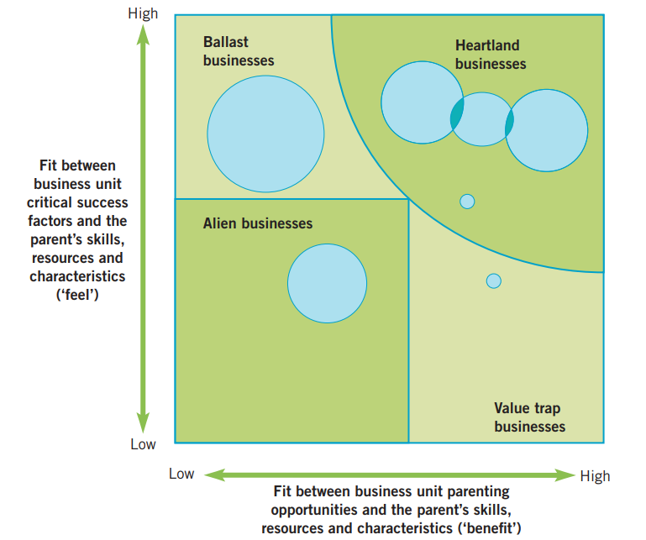

Where Cementary fits
Cementary Limited best matches “Edge of Heartland” (and could become Heartland if UIL has strong logistics capability).

Why:
Cementary operates in cement distribution, which is closely linked to UIL’s core cement value chain (related business).
Cementary lacks necessary skills, meaning there is parenting opportunity: UIL can add value through systems, controls, expertise, training, scale, and integration.
Advice: Should UIL acquire Cementary.
Yes-UIL should acquire Cementary, but only with strong integration and capability-building conditions, because it directly supports the cost leadership strategy by cutting distribution costs and improving Kigali market reach.

c) Why Cementary Limited is opposed to the proposed change
Cementary’s opposition is a common reaction in acquisitions and may be driven by:

Fear of loss of control and independence
Their board and owners may not want UIL to take over decision-making.

Job security concerns and restructuring risk
Staff and managers may fear layoffs, replacement, or stricter performance targets-especially since Cementary “lacks skills.”

Cultural resistance and identity threat
A small local firm may resist being absorbed into a larger corporate culture, systems, and reporting structures.

Perceived undervaluation or unfair deal terms
Cementary’s board may believe UIL’s offer undervalues the company or is opportunistic.

Personal interests and power dynamics
Directors/managers may resist because they stand to lose status, influence, benefits, or positions after acquisition.

End of Marking Guide and Model Answers

